Homework I:
UNIX System Administration & Security
Module: 5CS035 - Ethical Hacking (Week 1)

Instructions
Complete the following tasks on your Kali Linux environment (VM, WSL, or Labex).
For every task, you must provide a screenshot that clearly shows the terminal window, the command executed, and the resulting output. Ensure your username is visible in the prompt.

Task 1: Privilege Escalation & Sudo Configuration
In this task, you will simulate the process of a "Standard User" attempting to gain administrative (Root) access.
- Create a New User: Create a user named lab_user_01.
- Initial Restriction Test: Switch to lab_user_01. Attempt to run a root-only command using sudo ○ Note: This should fail with a message stating the user is not in the sudoers file.
- Return to Main User: Exit the lab_user_01 session to return to your main administrative account (or use exit).
- Grant Root Privileges: Add lab_user_01 to the sudo group so they can execute administrative commands.
- Final Verification: Switch back to lab_user_01 and run a command with sudo again. This time, it should succeed.
- Required Screenshot: Show the "Permission Denied" error from step 2 and the successful sudo command from step 5.

ANS:

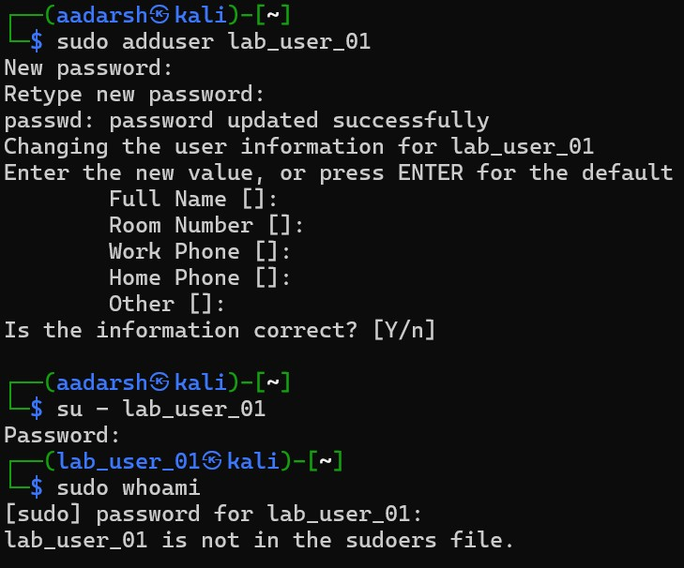

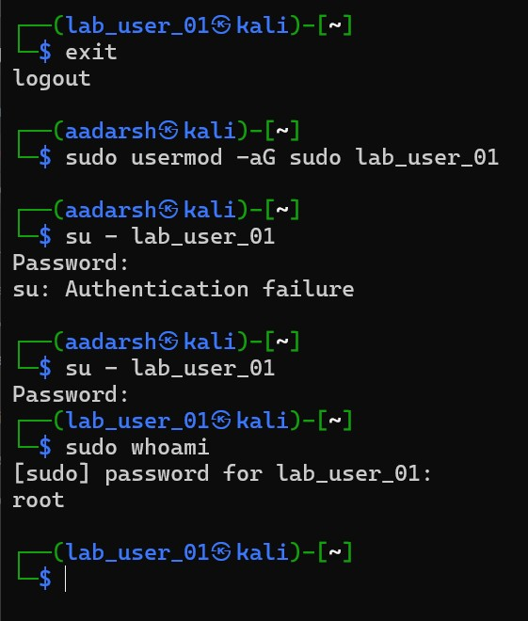

Task 2: Advanced Identity & Access Management
In this scenario, you will simulate a departmental structure by configuring specific access restrictions and group ownership inheritance:
- Create a new system group named security_audit.
- Create two new users: auditor_01 and dev_02.
- Assign auditor_01 to the security_audit group as a secondary group.
- Create a directory located at /tmp/audit_logs.
- Configure the system so that any new file created by auditor_01 within /tmp/audit_logs is automatically owned by the security_audit group.
Hints: Use sudo chgrp security_audit /tmp/audit_logs to change the directory's group ownership.
● Use sudo chmod g+s /tmp/audit_logs to apply the SetGID bit, which enforces group inheritance for new files.

Submission Requirements
To verify your configuration, provide a single screenshot or text output showing the results of the following commands:
- id auditor_01 (To verify group membership)
- ls -l /tmp/audit_logs (To verify directory permissions and the s bit)
ANS:
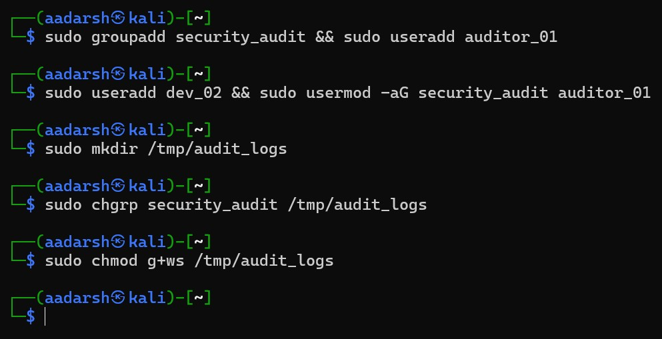
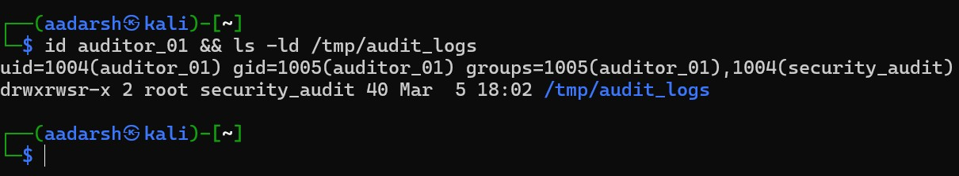

Task 3: Granular Permission Logic
- Create a file named top_secret.txt in your home directory.
- Using octal notation, configure the file permissions so that: ● The owner (user) has read and write permissions.
● The group has read-only permission. ● Others have no permissions.
- Modify the file permissions using symbolic or octal notation so that the final permission string appears as:

-rwxrwsrwt

Note: Unix systems support three special permission bits:
- setuid (SUID) – Executes the file with the privileges of the file owner.
- setgid (SGID) – Executes the file with the privileges of the file group.
- Sticky bit – Primarily used on directories to prevent users from deleting files owned by others within the same directory (e.g., /tmp).
4. Create a directory named shared_drop and use chmod to apply the sticky bit to it.

Note:
The t in a directory’s permission string indicates that the sticky bit is enabled. It does not prevent execution; it restricts deletion of files by non-owners within that directory. 5. Submit all the required Screenshots
ANS:
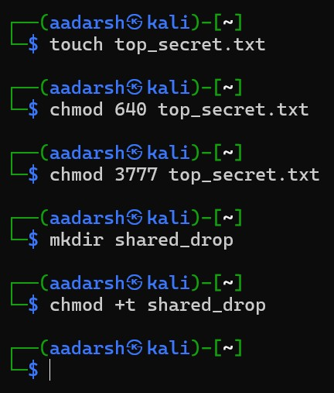
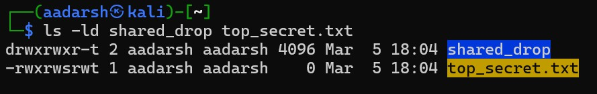

Task 4: Automated Reconnaissance Scripting
- Create a Bash script named sys_recon.sh.
- The script must output the following in a clean format, keep it simple, no need to use conditional statements for the following:
○ Current System Date/Time.
○ The Shell currently being used.
○ The last 5 lines of the system authorization log (usually /var/log/auth.log or /var/log/syslog).
- Make the script executable only by the owner.
- Required Screenshot: Show the content of the script (cat sys_recon.sh) and the successful execution of the script (./sys_recon.sh).

ANS:

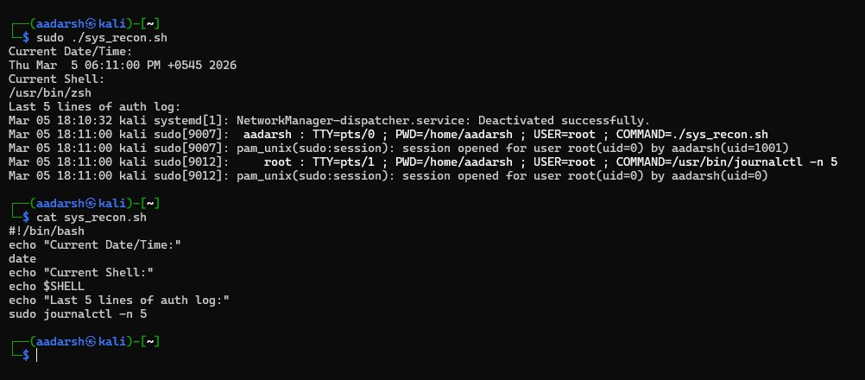

Submission Format
- Document: Submit a PDF file.
- Each page should have your name written on the top of the page. ● Submissions
should show the terminal window.

